California Statewide Medical and Health Exercise

Multi-Year Integrated Preparedness Plan (IPP)

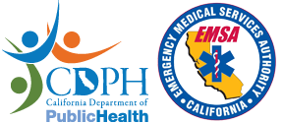

Acknowledgments
The annual California Statewide Medical and Health Exercise is sponsored by the California Department of Public Health (CDPH) and the California Emergency Medical Services Authority (EMSA). This Multi-Year Integrated Preparedness Plan (IPP, formerly MYTEP) was produced with input, advice, and assistance from key stakeholders including representatives of the Local Capabilities Working Group (LCWG), regional and local disaster planners, and the Statewide Medical and Health Exercise (SWMHE) Planning Workgroup (EPW).
- Association of Bay Area Health Officials (ABAHO)
- California Ambulatory Surgery Association (CASA)
- California Association of Health Facilities (CAHF)
- California Conference of Local Health Officers (CCLHO)
- California Department of Public Health (CDPH)
- California Emergency Medical Services Authority (EMSA)
- California Hospital Association (CHA)
- California Governor’s Office of Emergency Services (Cal OES)
- California Primary Care Association (CPCA)
- County of Riverside Emergency Management Department
- End Stage Renal Disease (ESRD) Network 17
- Inland Counties Emergency Management Agency
- Kaiser Permanente
- Los Angeles County Emergency Medical Services Agency
- Mariposa County Health and Human Services Agency
- Mendocino County Public Health Emergency Preparedness
- Napa County Emergency Medical Services Agency
- Regional Disaster Medical Health Coordinator Program
- Sacramento County Emergency Medical Services Agency
- San Diego County Public Health Preparedness Response
- San Joaquin County Emergency Medical Services Agency
- Satellite Healthcare Dialysis
- Sharp HealthCare

Sponsoring Agency Points of Contact

California Department of Public Health (CDPH) Contacts

Ryan Boyd
California Department of Public Health
Emergency Preparedness Office
1615 Capitol Avenue MS 7002 Sacramento, CA 95814
ryan.boyd@cdph.ca.gov

John Wogec
California Department of Public Health
Emergency Preparedness Office
1615 Capitol Avenue MS 7002 Sacramento, CA 95814
john.wogec@cdph.ca.gov
Telephone: (916) 862-4498

California Emergency Medical Services Authority (EMSA) Contacts

Craig Johnson
Chief, Disaster Medical Services Division
Emergency Medical Services Authority
Disaster Medical Services Division
10901 Gold Center Drive, Suite 400
Rancho Cordova, CA 95670
craig.johnson@emsa.ca.gov
Telephone: (916) 255-4171

Tiffany Cannon
Emergency Services Coordinator
Emergency Medical Services Authority
Disaster Medical Services Division
10901 Gold Center Drive, Suite 400
Rancho Cordova, CA 95670
tiffany.cannon@emsa.ca.gov
Telephone: (916) 539-5890

Multi-Year Integrated Preparedness Plan Review and Updates
The CDPH Local Capabilities Working Group (LCWG) and Statewide Medical and Health Exercise (SWMHE) Planning Workgroup (EPW) will review the IPP and its appendices annually. Suggested changes to the IPP will be incorporated and EPW will identify revisions, additions, or improvements needed.

Revisions noted in the annual plan review include:
- Continual update of information that may change regularly
- Formatting changes
- Text changes to incorporate new Hospital Preparedness Program (HPP) and Public Health Emergency Preparedness (PHEP) guidelines
- Text changes to incorporate organizational changes
- Text changes to incorporate findings from exercise evaluations
- Text changes to incorporate hazard vulnerability changes

Each time a change is made, the date and version number along with the noted change and author will be documented on the table below. Additional Plan Modification table rows may be added as necessary.

Table 1: Plan Modification Table

Date | Description of Change | Page Number | Author
9/14/18 | Updated yearly tables | 10 - 13 | c.schafer
7/15/19 | Updated acknowledgements, points of contact, and yearly tables to align with new grant requirements | 2-3,10-13 | a.slight
8/22/19 | Updated sponsoring agencies, points of contact, and added separate column for Health Care Coalition (HCC) Annexes as well as other considerations | 2-3,10-13 | a.slight
9/23/19 | Updated acronyms, Introduction, Training, and added an appendix (Regional Map) | 2,4,5-8 | a.slight
10/17/19 | Added “Anthrax” to Other Considerations for 2021 | 13 | a.slight
12/16/22 | Updated Acronyms, acknowledgment list, sponsors contacts, proposed IPP schedule, previous exercise schedule. Replaced HCC column with Medical Response and Surge Exercise (MRSE). Made document ADA compliant. | 1-18 | s.mier

Table of Contents
Acknowledgments 2
Sponsoring Agency Points of Contact 3
Multi-Year Integrated Preparedness Plan Review and Updates 4
Introduction 7
Training 10
Recommended Exercise Schedule 11
Appendix A: Previous Exercises 16
Appendix B: CAL OES Mutual Aid Region Map 19

Introduction
The purpose of this Multi-Year Integrated Preparedness Plan (IPP, formerly MYTEP) is to aid the Statewide Medical and Health Exercise (SWMHE) Planning Workgroup (EPW) participants with guidance and recommendations to accomplish the following:
- Identify priorities for improving preparedness and response capabilities of the organization
- Defining the cycle of training and exercise activities that will provide the most benefit in the development, refinement, and maintenance of those capabilities

Training and exercise schedules provided in this document illustrate proposed activities for the next five years. This is a working document that will be updated and refined on an annual basis or as necessary by the SWMHE EPW or through input from the Local Capabilities Workgroup (LCWG).

This document has been developed based on the capabilities, standards, guidelines, and grant requirements of greatest concern to participating jurisdictions and agencies. These include:
- Homeland Security Exercise and Evaluation Program (HSEEP)
The Homeland Security Exercise and Evaluation Program (HSEEP) provides a set of guiding principles for exercise programs, as well as a common approach to exercise program management, design and development, conduct, evaluation, and improvement planning. HSEEP exercise and evaluation doctrine is flexible, scalable, and adaptable, and is for use by stakeholders across the whole community. HSEEP doctrine is applicable for exercises across all mission areas prevention, protection, mitigation, response, and recovery. Using HSEEP supports the National Preparedness System by providing a consistent approach to exercises and measuring progress toward building, sustaining, and delivering core capabilities.
- Public Health Emergency Preparedness (PHEP)
The PHEP cooperative agreement provides funding for activities that are targeted specifically for the development of emergency-readiness in public health departments. PHEP funding is provided annually within a five-year cycle. Jurisdictions receiving funding must also test each of the 15 PHEP capabilities within the five-year grant cycle.
- Hospital Preparedness Program (HPP)
Administered by the US Department of Health and Human Services (DHHS) Office of the Administration for Strategic Preparedness and Response (ASPR), the HPP program provides grants to states, municipalities, and tribal governments to strengthen healthcare coalitions. Most of the funding is utilized by healthcare organizations to improve upon the four HPP capabilities, including medical surge.
- Medical Response and Surge Exercise (MRSE)
The MRSE is designed to examine and evaluate the ability of HCCs and other stakeholders to support medical surge, and specifically, how coalitions help patients receive the care they need at the right place, at the right time, and with the right resources during medical surge; decrease deaths, injuries, and illnesses resulting from medical surge; and promote health care delivery system resilience in the aftermath of medical surge.
- Centers for Medicaid and Medicare Services (CMS) Emergency Preparedness Rule
The Centers for Medicare and Medicaid Emergency Preparedness Rule establishes national emergency preparedness requirements to ensure adequate planning for both natural and man-made disasters, and coordination with federal, state, tribal, regional, and local emergency preparedness systems. The Rule requires a minimum level of disaster preparedness activities for 17 different CMS recipient health care facility types.
- Accrediting Organizations
Several organizations provide accreditation and certification to thousands of health care organizations. To achieve certification, a health care organization must adhere to recommended standards, some of which relate to emergency and disaster preparedness. Emergency preparedness standards touch on certain critical areas, and require that organizations have and test an Emergency Operations Plan on an annual basis.
- Cities Readiness Initiative (CRI)
CRI is a federal program within PHEP that provides funding to 72 Metropolitan Statistical Areas (MSA) to aid in developing efficient and accurate distribution and dispensing of medical countermeasures (MCM) from the Strategic National Stockpile (SNS) following a public health emergency. Recipients must exercise a bioterror event that would be able to test the transportation, distribution, and receipt of MCM at least once during the funding’s five-year cycle.
- Homeland Security Grant Program
Administered by the Department of Homeland Security within FEMA, the Homeland Security Grant Program provides hundreds of millions of dollars every year towards state, tribal, and local preparedness. Funds are received by a State Administrative Agency (SAA) and filtered down. Funds address the ability to mitigate, prepare for, respond to, and recover from acts of terrorism in high-threat, high-density urban areas. Funds are provided on an annual basis.

While this document may be helpful in planning for grant and accreditation requirements, it is not meant to directly fulfill PHEP or HPP requirements and serves only as a model. The document allows planners to view a schedule of future SWMHE Programs in order to better forecast and build their own Multi-Year Integrated Preparedness Plan (IPP, formerly MYTEP). The format has been modified from that of a more traditional IPP in order to accommodate the broader State perspective and with the intent of creating exercises that are inclusive of all participants in the State of California. The following resource may be useful for planners in creating their own IPP: https://preptoolkit.fema.gov/web/hseep-resources

Training
CDPH and EMSA offer multiple training opportunities and resources that can be found on https://www.cdph.ca.gov/Programs/EPO/Pages/swmhe_training.aspx or https://emsa.ca.gov/disaster-training/. Please visit these sites to view the trainings and find relevant information.
Planners should identify the training necessary to prepare themselves and their organizations for the recommended capabilities and objectives tested in the SWMHE each year. Planners should identify training that covers gaps revealed as part of the After Action Report/Improvement Plan process, and update their training schedule at least annually to reflect the accomplishments and progress of their organization.

Recommended Exercise Schedule
The following proposed schedule aims to ensure that every PHEP, HPP, MRSE capability is exercised within timeframes required by the grants and programs mentioned previously. Each year, the SWMHE Workgroup develops and finalizes a scenario which focuses on capabilities to be addressed in that year’s exercise and training activities. Planners will note that this document does not follow the same format as a full Multi-Year Integrated Preparedness Plan (IPP, formerly MYTEP), rather it lays out a capability-based five-year schedule. Planners can use this information as a foundation for their own IPP.

The “Regional Focus” column in the schedule reflects CDPH and EMSA’s desire to more closely simulate a real event occurring in one or more Mutual Aid Region of the state and allows for more intense and realistic exercise play between CDPH, EMSA and the designated region(s). All regions are still provided with the materials and direction to assist in development of a successful exercise, but the Medical and Health Coordination Center (MHCC) will play directly to the objectives and scenario of the Mutual Aid Region(s) identified under the “Regional Focus” during the SWMHE. This approach started in 2014 with the Region II Bay Area Mass Prophylaxis Working Group Anthrax Exercise and continued with the 2015 Region I and VI aerosolized anthrax bioterrorism exercise.
Feedback from SWMHE participants and local planners suggests that advanced knowledge of SWMHE capabilities and their associated scenarios for coming years would be of great assistance in planning exercises that align with CDPH play. In response, the IPP contains PHEP, HPP, and MRSE capabilities that will be targeted each year and suggested scenarios built from them. Caveats to these scenarios are:
- Real events (e.g., emerging public health emergencies and other disasters) can be disruptive to planned exercise capabilities, objectives, and scenarios. For example, CDPH and EMSA staff planned to fully support Mutual Aid Region II’s Aerosolized Anthrax exercise in 2014, but a “real-world” activation for the 2014 Ebola outbreak precluded involvement of the MHCC and many CDPH Emergency Preparedness Office staff in the exercise. While CDPH and EMSA will make every effort to play to SWMHE capabilities and scenarios within this IPP, they will remain flexible if health care organizations must respond to a real-world event or other specific objective.
- Suggested scenarios have been provided only after PHEP, HPP, and MRSE capabilities were set. For example, the SWMHE EPW did not initially develop a Mass Casualty Incident scenario for 2016. Rather, the EPW considered PHEP/HPP capabilities first, then developed a scenario that would suitably exercise those capabilities. This process is consistent with HSEEP best practices. The SWMHE Workgroup also tried to create a scenario that would test factors from the “Other Considerations” column of the IPP (formerly MYTEP) (see the following page).

Table 1: Proposed Multi-Year Preparedness Plan (IPP) Schedule
Year | Proposed PHEP Capabilities | Proposed HPP Capabilities | Medical Response and Surge Exercise (MRSE) Topic | Proposed National Core Capabilities | Suggested Scenario (s) | Other Considerations | Regional Focus
2023 | - Community Preparedness  - Community Recovery  - Emergency Operations Coordination  - Public Information and Emergency Public Information Warning  - Fatality Management  - Information Sharing  - Mass Care  - Medical Material Management and Distribution  - Medical Surge  - Responder Safety and Health  - Volunteer Management | - Medical Surge | Medical Surge | - Public Information and Warning  - Operational Coordination  - Intelligence and Information Sharing  - Community Resilience  - Fatality Management Services  - Logistics and Supply Chain Management  - Mass Care Services  - On-scene Security, Protection, and Law Enforcement  - Public Health, Healthcare, and Emergency Medical Services | Chemical fire | - Burn Surge  - Pediatric Surge | N/A
2024 | - Community Preparedness  - Community Recovery  - Emergency Operations Coordination  - Public Information and Emergency Public Information Warning  - Fatality Management  - Information Sharing  - Mass Care  - Medical Material Management and Distribution  - Medical Surge  - Responder Safety and Health  - Volunteer Management | - Medical Surge | Medical Surge | - Public Information and Warning  - Operational Coordination  - Intelligence and Information Sharing  - Community Resilience  - Fatality Management Services  - Logistics and Supply Chain Management  - Mass Care Services  - On-scene Security, Protection, and Law Enforcement  - Public Health, Healthcare, and Emergency Medical Services | Chemical fire | - Burn Surge  - Pediatric Surge | Region IV
2025 | - TBD | - TBD | Medical Surge | - TBD | Domestic Terror | - Water contamination | TBD
2026 | - TBD | - TBD | Medical Surge | - TBD | Cyber Event | - N/A | TBD
2027 | - TBD | - TBD | Medical Surge | - TBD | Electromagnetic Pulse (EMP) | - N/A | TBD
2028 | - TBD | - TBD | Medical Surge | - TBD | Infectious Disease | - N/A | TBD

Appendix A: Previous Exercises
In building a roadmap for success, the Federal Emergency Management Agency’s Homeland Security Exercise and Evaluation Program (HSEEP) guidance recommends that planners should have a strong idea of where they have been before they begin planning for where they want to go. As part of the Multi-Year Integrated Preparedness process, planners should review capabilities that have been previously tested. CDPH and EMSA have built prior exercises on national core/target, PHEP, and HPP capabilities. Past years of SWMHE exercises are listed below:

Table 2: Previous SWMHE Exercises
Year | Scenario(s) | Capabilities | Regional Focus
2011 | Disruption in the public water system | - Communications  - Intelligence/Information Sharing & Dissemination  - Medical Surge  - Emergency Operations Center (EOC) Management | N/A
2012 | Power loss due to an earthquake | Target Capabilities were Agency/Discipline specific and included:  - Communications  - EOC Management  - Intelligence and Information Sharing/Dissemination  - Medical Surge | N/A
2013 | Food-Borne Event | - Medical Surge  - Communication  - EOC Management  - Emergency Public Information and Warning  - Public Health Epidemiological Surveillance | N/A
2014 | MERS-CoV  Aerosolized Anthrax (Bay Area) | - Operational Communications  - Public Health and Medical Services  - Operational Coordination and On-Site Incident Management  - Public and Private Services and Resources | Region II
2015 | Pandemic Influenza  Aerosolized Anthrax (SoCal) | - Operational Communications  - Operational Coordination and On-Site Incident Management  - Public Health and Medical Services  - Medical Surge  - On-Scene Security  - Emergency Public Information and Warning  - Fatality Management  - Response/Health and Safety  - Critical Transportation | Region I  & VI
2016 | Mass Casualty Incident | - Community Preparedness  - Emergency Operations Coordination  - Emergency Medical Services  - Medical Surge  - Healthcare System Preparedness  - Operational Coordination | N/A
2017 | Terrorist Incident | - Information Sharing  - Emergency Public Information and Warning  - Community Recovery  - Emergency Operations Coordination  - Healthcare System Preparedness  - Mass Care Services | N/A
2018 | Infectious Disease | - Responder Safety and Health  - Non-Pharmaceutical Intervention  - Public Health & Epidemiology  - Environmental Response/Health and Safety Emergency Operations Coordination  - Information Sharing | Region IV
2019 | Flood | - Public Health and Medical Services  - Mass Care Services  - Public/Private Services and Resources | Region V

Appendix B: CAL OES Mutual Aid Region Map
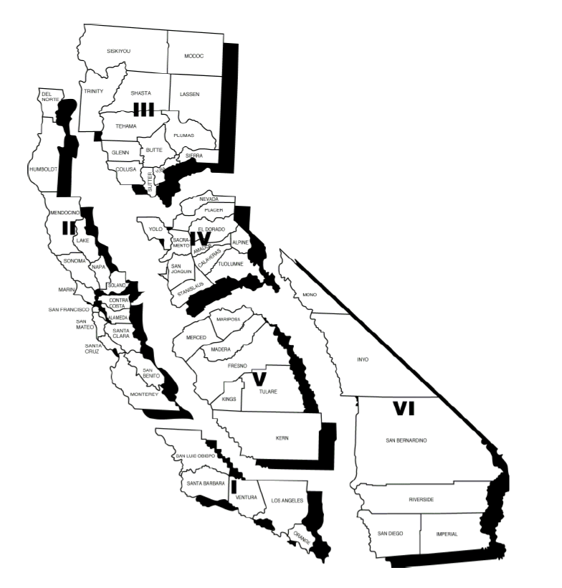

The latest guidance for the HPP grant now requires that healthcare coalitions create and test hazard or function-specific annexes each year. These topics have been pre-assigned, and the Statewide Medical and Health Exercise Planning Workgroup has attempted to align topics with chosen capabilities and scenarios for each year.
“Other Considerations” are inclusive of major grant requirements like UASI, TJC, or reflect capabilities SWMHE participants indicated they would like to test in the Forecasting Future SWMHE Programs Survey. These considerations are aligned with complimentary PHEP/HPP capabilities for each year, but can be tested (or not tested) according to needs established by each participating organization/agency.
California Governor’s Office of Emergency Services (Cal OES) Mutual Aid Regions. See Appendix B for the Region Map.

