School-Located Vaccine Events (SLVEs) Promotional Toolkit
This School-Located Vaccine Event (SLVE) Promotional Toolkit provides suggested materials to help protect students from diseases like influenza, COVID-19, or whooping cough, and promote SLVEs at your school. It includes content with shareable images and fields with fillable text for your school to use on social media platforms, websites, newsletters, and blogs. In addition, there are templates for email, text, robocall blasts, and press releases. Customizable banners, posters, flyers, school/district marquees, sporting event screens, and school/district calendars are also included. Families will need to hear early and often about your school’s events, and using multiple strategies will help your events succeed.
Questions? Email SchoolVaxTeam@cdph.ca.gov for support. For additional resources to support your event, including sample consent forms and training modules, please visit: Shots for School SLVE Page (bit.ly/CDPHSLVEResources).

Planning Materials and Resources for You:
Flyers and Posters Marquee/Sporting Event Screen Template
Banners School/District Calendars
Newsletter and Website Template Press Release Template
Family/Staff Email Templates Social Media Assets: Coming Soon
Newsletter and Website Template Social Media Assets: SLVE Awareness
Family/Staff Email Templates Social Media Assets: Back to School
Call-Outs (Robocall) Template Social Media Assets: Vaccine Awareness
Family and Staff Text Message Templates

Marketing Suggestions:
- Use all your regular channels to communicate with your families.
- Consider new communication strategies.
- Enlist art class/club to create SLVE signage and banners. Reuse these for annual events.
- Encourage teachers/staff to promote SLVEs using templates provided and include a personal note encouraging participation.
- Consider partnering with local media (radio, local magazines, and television) by sending requests for Public Service Announcements (PSA) using the template included in this toolkit, following up with phone calls.
- Consider partnering with Community Based Organizations (providers, youth centers, recreation programs, camps, student activity centers, and after school programs) to promote your SLVE.
- Involve your teachers/staff in sending consent form reminders and collecting forms; collection of consent forms increases when teachers are actively involved.

Information to Share When Promoting Your SLVE:
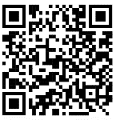
- Vaccine Information Statements (VIS) (bit.ly/CurrentVISIZOrg):
For any vaccines being offered at your events. This website hosts VISs that all families should read in advance of getting vaccinated. Most VISs are available in multiple languages.
- Recommended and Required vaccines for CA students:
Vaccines help keep our students healthy so they can keep growing, learning, and thriving. To view the CA Parent/Guardian Immunization Guide (bit.ly/ParentGuardianIZGuide).
- The Facts:
Share the facts about routine vaccines (bit.ly/CDCWhyVax), vaccine safety (bit.ly/CDCVaxSafety), and where you can get your child immunized if you are uninsured or underinsured (bit.ly/CDCWhere2BVaxedVFC).
- Vaccine Confidence Resources:
Vaccine resources from the Immunization Action Coalition (bit.ly/IZOrgVaxConfidence).

Flyers and Posters (electronic or paper):

Download Editable School Flyers/Posters (bit.ly/CDPH-IMM-1499):

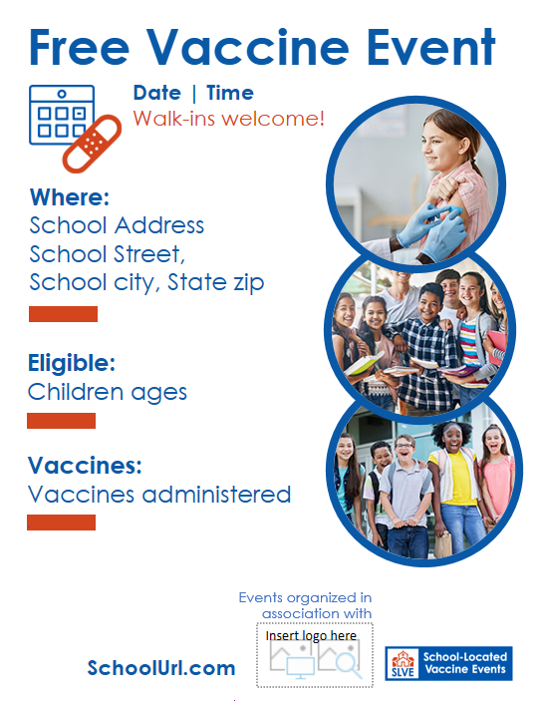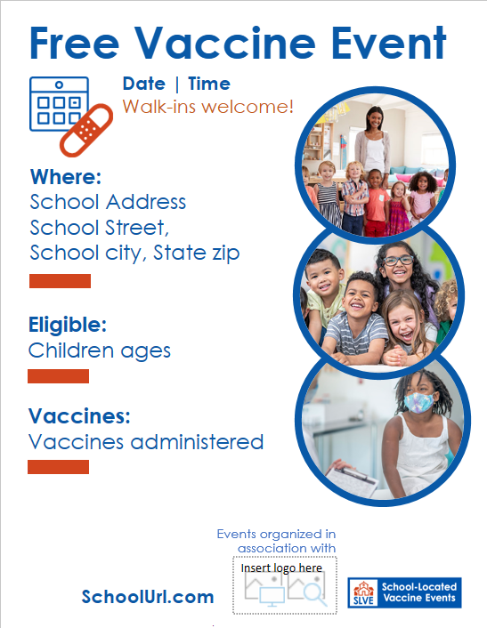
Middle School Flyer/Poster
Elementary School Flyer/Poster

Banners (electronic or physical):

Download Editable School Banners (bit.ly/CDPH-IMM-1497):
For physical banners that are printed, leaving fields that might change as a blank white box (such as event date or vaccines offered), allows you to reuse the banner by writing this information in with a dry erase marker.
Elementary School Banner
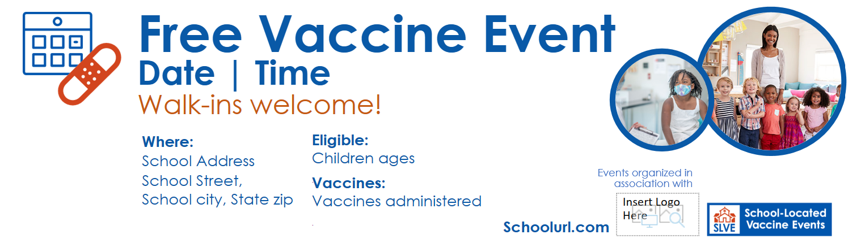
Middle School Banner
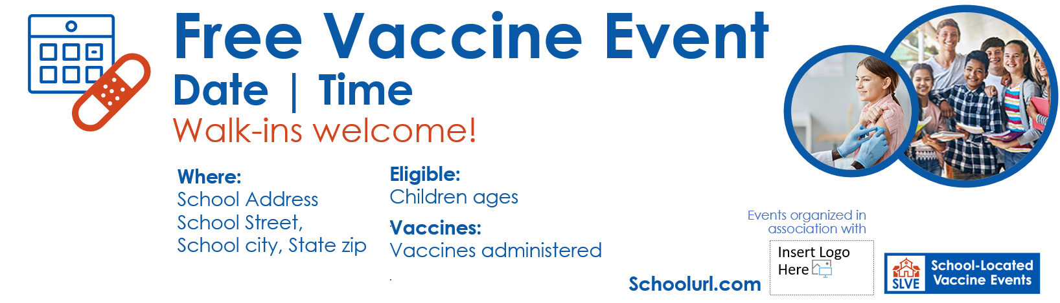

Newsletter and Website Template:
Mark your calendars! Free School-Located Vaccine Event Happening [insert date].
School-Located Vaccine Events can reduce a school’s absentee rates for students and staff. Protecting our school community is a top priority so [insert school name] will be hosting a FREE vaccination event on [insert date and time], at [insert address]. We will offer [list specific immunizations offered] to protect your [students, yourselves, family members, and even friends]. The event will take place on [insert date and time], at [insert address/school name].
Eligibility: [Insert those eligible to attend] are welcome to attend.
What to Bring: [Insert any required documents here].
How To Register: Visit [Insert URL for School-Located Vaccine Event].
Bilingual Support: If you need help in other languages, advance registration can be done by calling [insert telephone contact of language support for your school or remove this section if you are unable to accommodate].
[Insert Registration URL or QR Code]: Walk-ins accepted but early registration is appreciated.

Family/Staff Email Template:
Subject: FREE School-Located Vaccine Event at [insert school name here] on [insert date]
Message 1 for Families: Exciting News: It’s a great time to get immunizations on track! [Insert school name] is offering FREE vaccines to our school community. We will offer [list specific immunizations] to protect our [students, staff, family members, and friends]. The event will take place on [insert date and time], at [insert address/school name].
Message 2 for Staff: Exciting News! School-Located Vaccine Events can reduce school’s absentee rates for students and staff. Protecting our school community is a top priority so [insert school name] will be hosting a FREE vaccination event on [insert date and time], at [insert address/school room/location]. We will offer [list specific immunizations offered] to protect your students, [yourselves, family members, and even friends].
Eligibility: [Insert those eligible to attend] are welcome to attend.
What to Bring: [Insert any required documents here].
How To Register: Visit [Insert URL for School-Located Vaccine Event].
Bilingual Support: If you need help in other languages, advance registration can be done by calling [insert telephone contact of language support for your school or remove this section if you are unable to accommodate].
[Insert Registration URL or QR Code]: Walk-ins accepted but early registration is appreciated.

Call-Outs (robocall) Templates:
Message 1: Hi there! My name is [insert name of school contact] and I’m calling on behalf of [insert school name]. I’m calling to let you know that our school is hosting a FREE vaccine event on [insert SLVE date and time] for [insert participants: students, yourselves, family members, and even friends]. Please contact [insert school contact] or visit [insert method of contact/website/ phone] to learn more! Thank you and have a great day!
Message 2: Hi there! It’s [insert name of school contact], calling on behalf of [insert school name] to remind you about our upcoming FREE vaccine event on [insert SLVE date and time]. Please, don’t wait to vaccinate. Please contact [insert school contact] or visit [insert method of contact/website/phone] to learn more and access consent and registration materials! Thank you and have a great day!

Family and Staff Text Message Templates:
- Save The Date! It’s a great time for families and staff to get immunized and [insert school name] is making it easy and convenient for you. Our FREE School-Located Vaccine Event is on [insert date and time], at [insert address/school room/location]. Visit [insert link to school website] for more details! Register here [insert URL].

- Keep Our School Healthy! Help us protect our community and reduce school absenteeism by getting your students immunized. [Insert school name] is hosting a FREE School-Located Vaccine Event is on [insert date and time], at [insert school room/location]. Visit [insert link to school website] for details! Register here [insert URL].

- Keep Our Kids and Teachers in School! Protecting our school community and keeping students and teachers in school is a top priority for [insert school name]. Join us for a FREE School-Located Vaccine Event on [insert date and time], at [insert address/school /location]. Visit [insert link to school website] for more details! Register here [insert URL].

- Coming Soon! Please spread the news and join us at [insert school name] for a FREE School-Located Vaccine event on [insert date and time], at [insert school room/location]. Visit [insert link to school website] for more details! Register here [insert URL].

- Consent Form Reminder! Help protect our student’s health and take advantage of our free vaccine event on [insert date and time]. Visit [insert link to school website] for details and consent form links! Register here [insert URL].

- Today is The Day! [insert school name] is hosting a FREE School-Located Vaccine event today from [insert time] at [insert address/school room/location]. [Insert those eligible to attend] are invited to attend. Please bring [insert any required documents]. [Walk-ins welcome!] Register here [insert URL].

School Marquee or Sporting Event Screen Template:
Free Vaccine Event on [insert date and time] in [insert location-gym/library].

School/District Calendars (post weekly):
Four Weeks Before SLVE:
Save the Date: FREE Vaccine Event at [insert school name and address/school room/location] open to [insert those eligible to attend]. Visit [insert link to school website] for details! Register here [insert URL].
Three Weeks Before SLVE:
Spread the word: Students, their families, staff, and friends are invited to attend our free vaccine event. Visit [insert link to school website] for details! Register [insert URL].
Two Weeks Before SLVE:
Vaccine Event Consent Form Reminder: [Insert link to school website and consent forms].
One Week Before SLVE:
Vaccine Event Consent Form Reminder: Submit your consent forms here [insert link to school website and consent forms].
Day of SLVE:
Free Vaccine Event at [insert school name]. Register here [insert URL] or walk-in! All are welcome!

Social Media Assets: “Coming Soon” and “Save The Date”
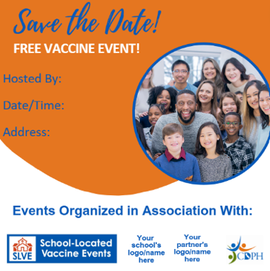
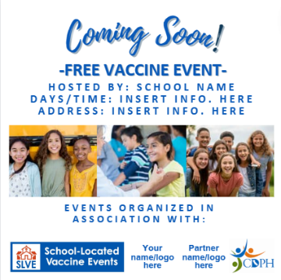
Download Editable Social Media Assets (bit.ly/CDPH-IMM-1498):
Posting 1: Make sure your student is protected!
FREE Vaccine Event open to [students, yourselves, family
members, and even friends] at [insert school name and
address/school room/location] on [insert date and time]!
Visit [insert link to school website] for details! Register here [insert URL].
Posting 2: Now is the time for families to get their students
vaccinated. [Insert school] is hosting a free vaccine event on
[insert date and time] at [insert school name and address/school room/location]! Mark your calendar. [Students, yourselves, family members, and even friends] are welcome to attend.
Visit [insert link to school website] for details! Register here [insert URL].

Social Media Assets: SLVE Awareness
Download Editable Social Media Assets (bit.ly/CDPH-IMM-1498):
Posting 1:
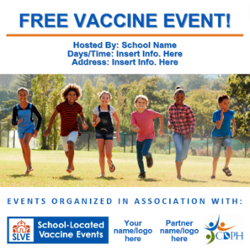
Make sure your student has all of their recommended vaccinations. FREE Vaccine Event open to [insert those eligible to attend] at [insert school name and address/school room/location] on [insert date and time].
Visit [insert link to school website] for details! Register here [insert URL].
#CaliforniaSLVE #DontWaitVaccinate #GetALLTheVaccines
Posting 2:
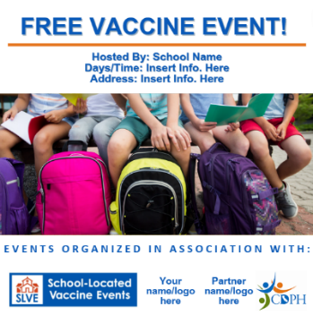
Now is the time for families to get their students recommended vaccines and [insert school name] is making that possible in a safe, familiar, convenient location! Mark your calendar for a FREE Vaccine Event on [insert date and time] open to [insert those eligible to attend] at [insert school name and address/school room/location].
Visit [insert link to school website] for details! Register here [insert URL].
#CaliforniaSLVE #DontWaitVaccinate #GetALLTheVaccines
Posting 3:
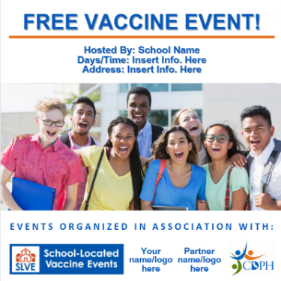
Staying up to date on ALL recommended vaccines
protects your student’s health and reduces school absenteeism. Please join us at our FREE vaccine event on [insert date and time] open to [insert those eligible to attend] at [insert school name and address/school room/location].
Visit [insert link to school website] for details! Register here [insert URL].
#CaliforniaSLVE #DontWaitVaccinate #GetALLTheVaccines

Social Media Assets: Back to School Checklist
Download Editable Files Social Media Assets (bit.ly/CDPH-IMM-1498):
Posting 1:
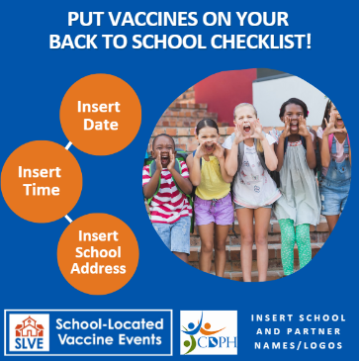
As the new school year approaches, be sure to add your student’s vaccinations to their back to school checklist. Staying up to date on ALL recommended vaccines protects your student’s health and reduces student and teacher absenteeism. Please join us at our FREE vaccine event on [insert date and time] open to [insert those eligible to attend] at [insert school name and address/school room/location].
Visit [insert link to school website] for details! Register here [insert URL].
#CaliforniaSLVE #DontWaitVaccinate #GetALLTheVaccines
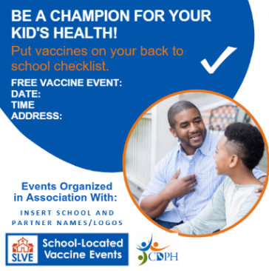
Posting 2:
Vaccinations help protect students from diseases, keeping them healthy so they can grow, learn, and thrive. Please join us at our FREE vaccine event offering [insert types of vaccines offered] on [insert date and time] open to [insert those eligible to attend] at [insert school name and address/school room/location].
Visit [insert link to school website] for details! Register here [insert URL].
#CaliforniaSLVE #DontWaitVaccinate #GetALLTheVaccines

Social Media Assets: General Vaccine Awareness
Download Editable Vaccine Awareness Assets: (bit.ly/CDPH-DontWaitVaccinate)
Posting 1:
Just like we need to update our phones and computers to keep them virus-free, our immune systems need updating, too. That's why [insert types of vaccines offered] [is/are] so important. Next time you visit the doctor, ask them about the [insert types of vaccines offered] for your child.

#DontWaitVaccinate Don’t Wait – Vaccinate! (bit.ly/CDPH-DontWaitVaccinate) #GetALLTheVaccines CDC Essential Vaccine Info (bit.ly/CDCEssentialVaccineInfo)

Press Release Template (Public Service Announcement):
[CITY/COUNTY]
[DATE]
To protect the health of our children and the community, students [insert additional audiences such as staff or the community] are invited to get vaccinated at [insert school(s)] on [insert clinic dates].

California Department of Public Health (CDPH) recommends all Californians stay up to date on all vaccines. Vaccines are one of the best ways to prevent disease. When students are not up to date on their vaccines, they are at risk for preventable disease and missing school. Vaccinating students at school can help meet the demand for convenient and timely vaccination of students while decreasing the burden on local health care providers, especially for seasonal vaccinations.

[Insert quote here, suggested quote: “I strongly support school-located vaccination as a strategy to protect as many of our children as possible,”] said [local health office or school official]. [Insert quote here, suggested quote: “Immunizations safeguard the health and future of our communities, particularly children. It is crucial to ensure that access to necessary vaccinations is convenient, timely and equitable.”]

Students from [insert grades] are eligible to receive [insert vaccine] during school hours. Receiving the vaccine is voluntary and at no cost for students, with or without insurance. For students to get vaccinated, parents/guardians must complete and return a consent form, available from schools. School Staff may also receive their [insert vaccine], at no cost.

For more information on the vaccine(s) offered at this event please refer to the current Vaccine Information Statements at Immunization Action Coalition (bit.ly/CurrentVISIZOrg).

[Add local health department (LHD) contact info if applicable]
If you have any questions about the vaccination events, please call [insert contact name] at [insert phone number].

Planning Materials and Resources for You:
Please visit CDPH SLVE Resources (bit.ly/CDPHSLVEResources) for additional planning materials and resources.

