Facebook Frame
As flu season ramps up, it’s important to encourage all your followers to receive their annual flu shot. This social media toolkit discusses how to use CDPH’s Facebook frames by members of your community as a reminder that they all need to #fightflutogether by getting their flu shot.

Facebook Frame Step-by-Step Instructions:
1. Hover over your profile photo and select “Update.”
2. Select “Add Frame.”
3. In the search box, type in “I got my flu shot” or “Me vacuné contra la influenza.”
4. Select the appropriate frame.
5. Drag to reposition your profile picture if needed.
6. Select “Timeframe” from the drop down when you want to switch back to your previous profile picture
7. Select “Use as Profile Picture” to save.
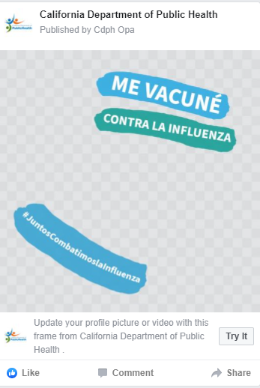
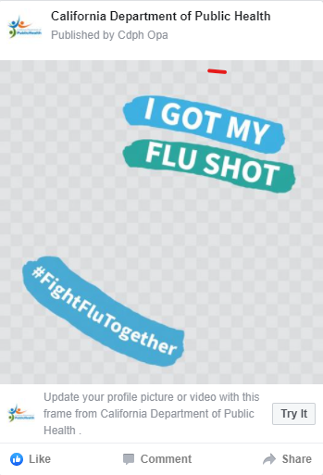

You can also use these links to direct your followers to the appropriate frame:
“I got my flu shot”
“Me vacuné contra la influenza”

Language to use once you update your profile pic:
While we don’t have a vaccine for COVID-19 yet, we do have one for flu. It’s a safe and easy way to protect you, your family and your community from this treatable infectious disease. Help spread the word. Get your flu shot, update your profile picture and let’s #FightFluTogether. Visit cdph.ca.gov/fightflu to learn more.

