Sample Certificate Border

Certificate of Participation

This is to certify that

[Enter First and Last Name]

[jurisdiction/organization/facility]

Participated in the

**Statewide Medical and Health Exercise**

On

[Insert day of week], [Insert month and day], [Insert year]

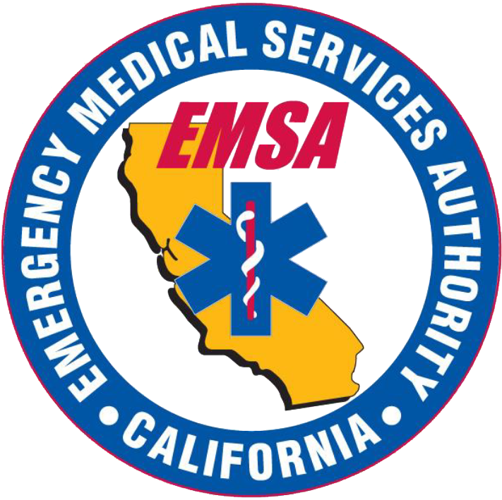California Department of Public Health Logo[Insert location]