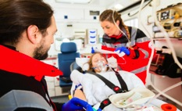

2023 Statewide Medical and Health Exercise

Save the Date
When:
[Insert date] - Tabletop Exercise
[Insert date] - Controller/Evaluator Training
[Insert date] - Functional Exercise
[Insert date] - After Action Meeting
Time:
[Insert time]
Where:
[Insert location]

For additional information on the
California Statewide Medical and Health Exercise,
Visit https://www.cdph.ca.gov/Programs/
EPO/Pages/swmhe.aspx

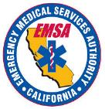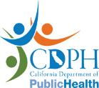

Overview
The California Statewide Medical and Health Exercise (SWMHE) will be held on [insert date] from [insert time] to [insert time] at the [jurisdiction/organization/facility name here].
Participating organizations include:
- [list participating jurisdictions/organizations/facilities here]
- [list participating jurisdictions/organizations/facilities here]
- [list participating jurisdictions/organizations/facilities here]

Objectives
Exercise objectives include:
- [Insert exercise objectives here]
- [Insert exercise objectives here]
- [Insert exercise objectives here]

Point of Contact
You are invited to share this ‘save the date’ with interested agencies and organizations. For more information, or if your agency or organization is interested in participating in the [jurisdiction/organization/facility name here] SWMHE, please contact:
[Name, Title]
[Agency]
[Email]
[Telephone]

