2023 Statewide Medical and Health Exercise

Player Badge

**PLAYER**

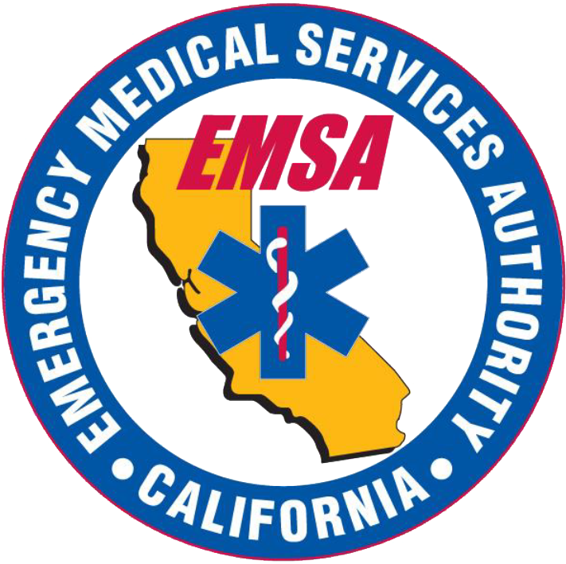

**Statewide Medical and Health Exercise**

| Player Information |
| --- |
| [A list of the objectives and capabilities being tested during the exercise can be found in the Exercise Plan]   * [Objective 1] * [Objective 2] * [Objective 3] |
| * Exercise staff may be identified by [badges, hats, and/or vests] to clearly display exercise roles; additionally, uniform clothing may be worn to show agency affiliation. * Exercise participant safety takes priority over exercise events. * If a real-world emergency occurs, inform the nearest Controller using the phrase “[This Is Not a Drill]”. Immediately and call 9-1-1 if necessary. * Exercise players will comply with real-world emergency procedures, unless otherwise directed by the control staff. |

## Exercise Schedule

| Time | Who | Activity | Location |
| --- | --- | --- | --- |
| [Insert Time] | Controllers and Exercise Staff | Check-in for final instructions and communications check | [Insert Location] |
| [Insert Time] | Media | Media Briefing | [Insert Location] |
| [Insert Time] | VIP & Selected Exercise Staff | VIP Controller Briefing | [Insert Location] |
| [Insert Time] | All Players | Player Briefing | [Insert Location] |
| [Insert Time] | **All** | **Exercise Starts** | [Insert Location] |
| [Insert Time] | **All** | **Exercise Ends** | [Insert Location] |
| Immediately Following the Exercise | All | Venue Hot Washes  Turn in all Participant Feedback Forms | [Insert Location] |