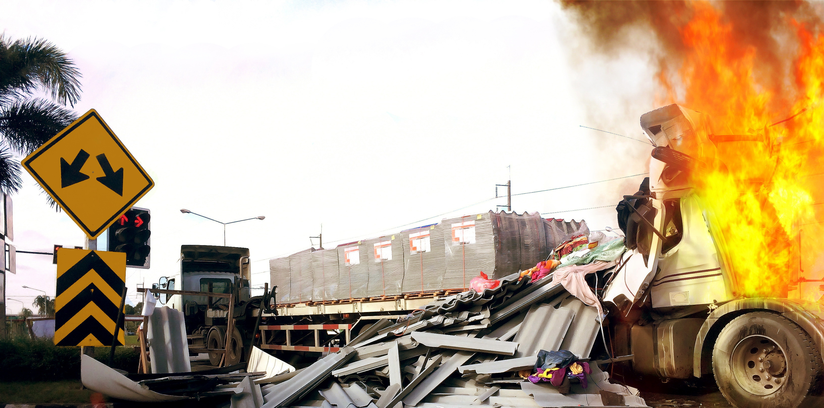

2023 Statewide Medical and Health Exercise

Exercise Plan

Chemical Fire with Burn and Pediatric Surge



Preface

The 2023 California Statewide Medical and Health Exercise (SWMHE) is sponsored by the California Department of Public Health (CDPH) and the Emergency Medical Services Authority (EMSA). This Exercise Plan (ExPlan) was produced with input, advice, and assistance from the SWMHE Planning Workgroup, comprised of representatives from:

- Association of Bay Area Health Officials (ABAHO)
- California Ambulatory Surgery Association (CASA)
- California Association of Health Facilities (CAHF)
- California Conference of Local Health Officers (CCLHO)
- California Department of Public Health (CDPH)
- California Emergency Medical Services Authority (EMSA)
- California Hospital Association (CHA)
- California Governor’s Office of Emergency Services (Cal OES)
- California Primary Care Association (CPCA)
- County of Riverside Emergency Management Department
- End Stage Renal Disease (ESRD) Network 17
- Inland Counties Emergency Management Agency
- Kaiser Permanente
- Los Angeles County Emergency Medical Services Agency
- Mariposa County Health and Human Services Agency
- Mendocino County Public Health Emergency Preparedness
- Napa County Emergency Medical Services Agency
- Regional Disaster Medical Health Coordinator Program
- Sacramento County Emergency Medical Services Agency
- San Diego County Public Health Preparedness Response
- San Joaquin County Emergency Medical Services Agency
- Satellite Healthcare Dialysis
- Sharp HealthCare

The ExPlan follows guidelines set forth by the U.S. Federal Emergency Management Agency (FEMA) Homeland Security Exercise and Evaluation Program (HSEEP). The ExPlan gives participating organizations the information necessary to take part in an operations-based functional exercise (FE) or full-scale exercise. See [Appendix I] for a listing of agency/event acronyms. All exercise participants should use appropriate guidelines to ensure proper control of information within their areas of expertise and protect this material in accordance with current jurisdictional directives.

[Customizing the Exercise Plan]

[Throughout the ExPlan, there are opportunities for customization by jurisdiction/organization/facility planners. This document serves as a template guidance document. This ExPlan, and particularly the objectives, schedule, and venue details, should be modified to reflect the unique characteristics of your region and participants. Bracketed text (e.g., [your jurisdiction]) is provided to aid with location-specific customization. These should be removed or modified as appropriate prior to finalizing this document. Exercise planners can insert their customized language and then remove the highlight and brackets. After customizing the document to your jurisdiction/organization/facility, be sure to update the Table of Contents by right clicking on it and selecting “update field.”]

Table of Contents
Preface 2
[Customizing the Exercise Plan] 3
Table of Contents 4
Exercise Overview 6
General Information 8
Exercise Objectives & Capabilities 8
Participant Roles & Responsibilities 9
Exercise Assumptions & Artificialities 11
Functional Exercise Tools 11
Exercise Logistics 12
Safety 12
Site Access 13
Parking & Transportation 14
Registration/Check-in 14
Lunch 14
Cleanup & Restoration 14
Post-Exercise & Evaluation Activities 15
Debriefings 15
Evaluation 15
Improvement Planning 16
Participant Information & Guidance 17
Exercise Rules 17
Player Instructions 17
Simulation Guidelines 18
Appendix A: Exercise Schedule 19
Appendix B: Exercise Participants 21
Appendix C: Communications Plan 22
Player Communications 22
Controller Communications 22
Communications Check 22
Player Briefing 22
Public Affairs 23
Communications Directory 24
Appendix D: Exercise Site Maps 25
Appendix E: [Scenario Specific Guidelines or Resources] 26
Burn Resources 26
Surge Resources 26
Chemical Resources 26
Medical Response and Surge Exercise (MRSE) Objectives 26
Appendix F: Communication & Information Management 27
Appendix G: Forms 36
Appendix H: Safety Checklist 37
Site Control/Scene Safety 37
Participant Safety 37
Appendix I: Acronyms 38

Exercise Overview

Exercise Name | [Insert Year] California Statewide Medical and Health Exercise (SWMHE) – [Functional Exercise (FE) or Full-Scale Exercise]
Exercise Date | [Insert Jurisdiction/Organization/Facility’s Exercise Date]
Scope | This is an exercise planned for [Jurisdiction/Organization/Facility] to take place at [insert exercise date and time] at [insert exercise location]. The 2023 SWMHE Program is a progressive exercise program comprised of a series of training exercises tied to a set of common program priorities. This year’s exercise is a multiphase program culminating in the exercise on [insert date of play]. An After Action Meeting (AAM) will be conducted within 60 days of the exercise.
Mission Area(s) | [Insert mission area(s)]
Capabilities | [Based on the capabilities selected for your exercise, whether you are using Public Health Emergency Preparedness (PHEP), Health Care Preparedness and Response Capabilities, or National Core Capabilities (or a combination), please list them here. These should be selected based on your objectives and requirements for the exercise.]  - [Public Health, Healthcare, and Emergency Medical Services (Core)]  - [Operational Communications (Core)]  - [Situational Assessment (Core)]  - [Operational Coordination (Core)]  - [Public Information and Warning (Core)]  - [Mass Care Services (Core)]  - [Health Care and Medical Response Coordination (Health Care Preparedness and Response Capabilities)]  - [Continuity of Health Care Service Delivery (Health Care Preparedness and Response Capabilities)]  - [Information Sharing (PHEP)]  - [Emergency Operations Coordination (PHEP)]  - [Emergency Public Information and Warning (PHEP)]  - [Responder Safety and Health (PHEP)]
Objectives | [For sample objectives, please refer to the Objectives template documents for Ambulance, Behavioral Health, Community Clinics, Coroner/Medical Examiner, Emergency Medical Services (EMS) Agencies, Fire, Hospitals, Law Enforcement, Long Term Care Facilities, Offices of Emergency Management, and Public Health.]
Scenario | [Insert scenario]
Sponsor | The 2023 SWMHE is sponsored by the California Department of Public Health (CDPH) and Emergency Medical Services Authority (EMSA) in collaboration with response partners representing local health departments, public safety and healthcare facilities across California.
Participating Organizations | [Insert participating organizations here and in the appendices]

General Information

Exercise Objectives & Capabilities

The exercise objectives in Table 1 describe expected outcomes for the exercise. The objectives are linked to [Public Health Emergency Program (PHEP) / Health Care Preparedness and Response / National Core/ Hospital Preparedness Program (HPP)/ Medical Response and Surge Exercise (MRSE)] capabilities, which are elements necessary to achieve the specific mission area(s). The objectives and aligned capabilities are guided and selected by the Exercise Planning Team and are listed in Appendix E.

[Please insert the objectives that are most relevant and applicable to your agency/organization in Table 1. According to the Federal Emergency Management Agency’s (FEMA) Emergency Management Institute and general Homeland Security Exercise and Evaluation Program (HSEEP) guidelines, ten or fewer objectives are recommended for an exercise.]
The objectives listed below are those tailored for this exercise. A set of example objectives customized for different participating agencies and organizations (Ambulance, Behavioral Health, Community Clinics, Coroner/Medical Examiner, Emergency Medical Services [EMS] Agencies, Fire, Hospital, Law Enforcement, Long Term Care Facilities, Offices of Emergency Management, and Public Health) is available at https://www.cdph.ca.gov/Programs/EPO/Pages/swmhe_current.aspx.

Table 1: Exercise Objectives and Associated Capabilities
Exercise Objective | Capability
[Insert Jurisdiction/Organization/Facility’s selected objectives] | [Insert Jurisdiction/Organization/Facility’s selected capabilities]
[Insert Jurisdiction/Organization/Facility’s selected objectives] | [Insert Jurisdiction/Organization/Facility’s selected capabilities]
[Insert Jurisdiction/Organization/Facility’s selected objectives] | [Insert Jurisdiction/Organization/Facility’s selected capabilities]
[Insert Jurisdiction/Organization/Facility’s selected objectives] | [Insert Jurisdiction/Organization/Facility’s selected capabilities]
[Insert Jurisdiction/Organization/Facility’s selected objectives] | [Insert Jurisdiction/Organization/Facility’s selected capabilities]
[Insert Jurisdiction/Organization/Facility’s selected objectives] | [Insert Jurisdiction/Organization/Facility’s selected capabilities]
[Insert Jurisdiction/Organization/Facility’s selected objectives] | [Insert Jurisdiction/Organization/Facility’s selected capabilities]
[Insert Jurisdiction/Organization/Facility’s selected objectives] | [Insert Jurisdiction/Organization/Facility’s selected capabilities]
[Insert Jurisdiction/Organization/Facility’s selected objectives] | [Insert Jurisdiction/Organization/Facility’s selected capabilities]

Participant Roles & Responsibilities

The term participant encompasses many groups of people, not just those playing in the exercise. Groups of participants, and their respective roles and responsibilities, are as follows:

- Players. Players are personnel who have an active role in discussing or performing their response roles and actions during the exercise. Players discuss or initiate actions in response to the simulated emergency.
- Exercise Director. The Exercise Director oversees all exercise functions during exercise conduct, oversees and remains in contact with controllers and evaluators, debriefs controllers and evaluators following the exercise, and oversees setup and cleanup of the exercise as well as positioning of controllers and evaluators.
- Safety Controller. The Safety Controller monitors exercise activities and advises the Exercise Director on all matters relating to incident health and safety of all exercise participants. The Safety Controller has emergency authority to stop and/or prevent unsafe acts during incident operations.
- Controllers. Controllers plan and manage exercise play, set up and operate the exercise site, and act in the roles of organizations or individuals that are not playing in the exercise. Controllers direct the pace of the exercise, provide key data to players, and may prompt or initiate certain player actions to ensure exercise continuity. In addition, they issue exercise material to players as required, monitor the exercise timeline, and supervise the safety of all exercise participants.
- Simulators. Simulators are control staff personnel who role-play nonparticipating organizations or individuals. They most often operate out of the Simulation Cell (SimCell), but they may occasionally have face-to-face contact with players. Simulators function semi-independently under the supervision of SimCell controllers, enacting roles (e.g., media reporters or next of kin) in accordance with instructions provided in the Master Scenario Events List (MSEL). All simulators are ultimately accountable to the Exercise Director and Senior Controller.
- Evaluators. Evaluators evaluate and provide feedback on a designated functional area of the exercise. Evaluators observe and document performance against established capability targets and critical tasks, in accordance with the Exercise Evaluation Guides (EEG).
- Actors. Actors simulate specific roles during exercise play, typically victims or other bystanders. [Delete bullet if not applicable]
- Observers. Observers visit or view selected segments of the exercise. Observers do not play in the exercise, nor do they perform any control or evaluation functions. Observers view the exercise from a designated observation area and must remain within the observation area during the exercise. Very Important Persons (VIPs) are also observers, but they are often grouped separately.
- Media Personnel. Some media personnel may be present as observers, pending approval by the sponsor organization and the Exercise Planning Team. [Delete bullet if not applicable]
- Support Staff. The exercise support staff includes individuals who perform administrative and logistical support tasks during the exercise (e.g., registration, catering).

Exercise Assumptions & Artificialities

In any exercise, assumptions and artificialities may be necessary to complete play in the time allotted and/or account for logistical limitations. Exercise participants should accept that assumptions and artificialities are inherent in any exercise, and should not allow these considerations to negatively impact their participation.

Assumptions constitute the implied factual foundation for the exercise and, as such, are assumed to be present before the exercise starts. The following assumptions and/or artificialities apply to the exercise:

- [The exercise is conducted in a no-fault learning environment wherein capabilities, plans, systems, and processes will be evaluated.]
- [The exercise scenario is plausible, and events occur as they are presented.]
- [exercise simulation contains sufficient detail to allow players to react to information and situations as they are presented as if the simulated incident were real.]
- [Participating agencies may need to balance exercise play with real-world emergencies.
Real-world emergencies take priority.]
- [Decisions are not precedent setting and may not reflect your organization’s final position.]
- [Time lapses may be inserted to achieve the exercise objectives.]
- [Impacts are seen across the spectrum of the response community.]
- [Participants should use existing plans, policies, and procedures. If during the course of the exercise there is disagreement with existing plans, policies, and procedures, this should be noted, and relevant stakeholders should assess the need to change documents after the exercise.]
- [There are no “hidden agendas” or trick questions.]
- [All players receive information at the same time.]
- [If a player would normally contact an individual or department that is not represented at the exercise, they should tell the SimCell what information they need and who they would contact. This action should be noted.]
- [Include any additional assumptions / artificialities to be used in the exercise.]

Functional Exercise Tools

[In addition to this document, several tools have been developed by California Department of Public Health (CDPH) to aid healthcare entities and their partners in the development of their exercise. Other tools available on https://www.cdph.ca.gov/Programs/EPO/Pages/swmhe_current.aspx include:]

- [Scenario Summary]
- [Exercise Evaluation Guide (EEG)]
- [After Action Report (AAR) Template]
- [Actor Cards Template]
- [Objectives]
- [Master Scenario Events List (MSEL)]
- [Player Handout]
- [Additional Resources]

Exercise Logistics

[Each agency should fill in logistics information specific to their exercise.]

Safety

Exercise participant safety takes priority over exercise events. The following general requirements apply to the exercise:

- A Safety Controller is responsible for participant safety; any safety concerns must be immediately reported to the Safety Controller. The Safety Controller and Exercise Director will determine if a real-world emergency warrants a pause in exercise play and when exercise play can be resumed.
- For an emergency that requires assistance, use the phrase [“This is not a drill.”]
The following procedures should be used in case of a real emergency during the exercise:
  - Anyone who observes a participant who is seriously ill or injured will immediately notify emergency services and the closest controller, and, within reason and training, render aid.
  - A controller aware of a real emergency will initiate the [“This is not a drill”] broadcast and provide the Safety Controller, Senior Controller, and Exercise Director with the location of the emergency and resources needed, if any. The Senior Controller will notify the [Control Cell or Simulation Cell (SimCell)] as soon as possible.

Fire Safety [delete section if not applicable]
Standard fire and safety regulations relevant to the [jurisdiction, venue, or organization] will be followed during the exercise. [Insert any organization or venue-specific guidelines/protocols]

Emergency Medical Services [delete section if not applicable]
The sponsor organization will coordinate with local Emergency Medical Services (EMS) in the event of a real-world emergency. [Insert any organization or venue-specific guidelines/protocols]

Electrical and Generating Device Hazards [delete section if not applicable]
All applicable electrical and generating device safety requirements should be documented prior to the start of the exercise. [Insert any organization or venue-specific guidelines/protocols]

Weapons Policy [delete section if not applicable]
All participants will follow the relevant weapons policy for the exercising organization or exercise venue.

Site Access

Security
If entry control is required for the exercise venue(s), the sponsor organization is responsible for arranging appropriate security measures. Access to exercise sites and the [Control Cell and/or SimCell] is limited to exercise participants to prevent interruption of the exercise. Players should advise their venue’s controller or evaluator of any unauthorized persons.

Media/Observer Coordination [delete section if not applicable]
Organizations with media personnel and/or observers attending the event should coordinate with the sponsor organization for access to the exercise site. Media/Observers are escorted to designated areas and accompanied by an exercise controller at all times. Sponsor organization representatives and/or the observer controller may be present to explain exercise conduct and answer questions. Exercise participants should be advised of media and/or observer presence.

Exercise Identification [delete section if not applicable]
Exercise staff may be identified by badges, hats, and/or vests that clearly display exercise roles; additionally, uniform clothing may be worn to show agency affiliation. Table 2 describes these identification items.

Table 2: Exercise Identification
Group | Color
[Exercise Director]
[Controllers]
[Evaluators]
[Actors]
[Support Staff]
[Observers/VIPs]
[Media Personnel]
[Players, Uniformed]
[Players, Civilian Clothes]

Parking & Transportation

Parking will be available at the exercise sites. Public transportation options are also available.
[Add parking information]

Registration/Check-in

All participants should check in prior to the exercise and receive instructions on facility characteristics.
[Add registration time and location]

Lunch

Food and refreshments will be provided for all exercise participants. [Add lunch time and location information. Delete if not applicable]

Cleanup & Restoration

After the exercise, controllers, evaluators, and players will begin cleanup operations to restore the area to pre- exercise conditions. All participating organizations will assist in these efforts.

Post-Exercise & Evaluation Activities

For a full exercise schedule, including the time and location of all post- exercise meetings, please see [Appendix A].

Debriefings
Post- exercise debriefings aim to collect sufficient relevant data to support effective evaluation and improvement planning.

Hot Wash
At the conclusion of exercise play, controllers facilitate a Hot Wash to allow players to discuss strengths and areas for improvement, and evaluators to seek clarification regarding player actions and decision-making processes. All participants may attend; however, observers are not encouraged to attend the meeting. The Hot Wash should not exceed 30 minutes.

Controller & Evaluator Debriefing
Immediately following the exercise, controllers and evaluators attend a facilitated Controller/Evaluator (C/E) debriefing where they provide an overview of their observed functional areas and discuss strengths and areas for improvement.

Participant Feedback Forms
Participant Feedback Forms provide players with the opportunity to comment candidly on exercise activities and design. These forms should be collected at the conclusion of the Hot Wash.

Evaluation

Exercise Evaluation Guides
Exercise Evaluation Guides (EEG) assist evaluators in collecting relevant exercise observations. EEGs document exercise objectives and aligned capabilities, capability targets, and critical tasks. Each EEG provides evaluators with information on what they should expect to see demonstrated in their functional area. The EEGs, coupled with Participant Feedback Forms and Hot Wash notes, are used to evaluate the exercise and compile the After-Action Report (AAR).

After-Action Report
The AAR summarizes key information related to evaluation. It primarily focuses on the analysis of capabilities, including capability performance, strengths, and areas for improvement. The AAR also includes basic exercise information, including the exercise name, type, dates, location, participating organizations, mission area(s), specific threat or hazard, a brief scenario description, and the name of the exercise sponsor and point of contact (POC).

Improvement Planning
Improvement planning is the process by which the observations recorded in the AAR are resolved through development of concrete corrective actions, which are prioritized and tracked as part of a continuous corrective action program.

After-Action Meeting
The After-Action Meeting (AAM) is held among decision- and policy-makers from the exercising organizations, the Lead Evaluator, and members of the Exercise Planning Team to debrief the exercise and review/refine the draft AAR and Improvement Plan (IP). The AAM should be an interactive session, providing attendees the opportunity to discuss/validate the observations and corrective actions in the draft AAR/IP.

Improvement Plan
The IP identifies specific corrective actions, assigns them to responsible parties, and establishes target dates for their completion. It is created by elected and appointed officials from participating organizations and discussed/validated during the AAM.

Participant Information & Guidance

Exercise Rules

The following general rules govern exercise play:

- Real-world emergency actions take priority over exercise actions.
- Exercise players will comply with real-world emergency procedures, unless otherwise directed by control staff.
- All communications (including written, radio, telephone, and e-mail) during the exercise will begin and end with the statement [“This is an exercise.”]
- Exercise players who place telephone calls or initiate radio communication with the Simulation Cell (SimCell) must identify the organization or individual with whom they wish to speak.
- [Insert your jurisdiction/organization/facility’s specific rules here.]

Player Instructions

Players should follow certain guidelines before, during, and after to ensure a safe and effective exercise.

Before the Exercise
- Review appropriate organizational plans, procedures, and exercise support documents.
- Be at the appropriate site at least 30 minutes before the exercise starts. Wear the appropriate uniform and/or identification item(s).
- Sign in when you arrive.
- If you gain knowledge of the scenario before the exercise, notify a controller so that appropriate actions can be taken to ensure a valid evaluation.
- [Read your Player Handout, which includes information on exercise safety.]
- [Insert your jurisdiction/organization/facility’s specific tasks here.]

During the Exercise
- Respond to exercise events and information as if the emergency were real, unless otherwise directed by an exercise controller.
- Controllers will only give you information they are specifically directed to disseminate. You are expected to obtain other necessary information through existing emergency information channels.
- Do not engage in personal conversations with controllers, evaluators, observers, or media personnel. If asked an exercise-related question, give a concise answer. If you are busy and cannot immediately respond, indicate that, but report back with an answer as soon as possible.
- If you do not understand the scope of the exercise or are uncertain about an organization’s participation in an exercise, ask a controller.
- Parts of the scenario may seem implausible. Recognize that the exercise has objectives to satisfy that may require incorporation of unrealistic aspects. Every effort has been made to balance realism with safety, and to create an effective learning and evaluation environment.
- All exercise communications will begin and end with the statement [“This is an exercise.”] This precaution is taken so that anyone who overhears the conversation will not mistake exercise play for a real-world emergency.
- When you communicate with the SimCell, identify the organization or individual with whom you wish to speak.
- Speak when you take an action. This procedure will ensure that evaluators are aware of critical actions as they occur.
- Maintain a log of your activities. Many times, this log may include documentation of activities that were missed by a controller or evaluator.
- [Insert your jurisdiction/organization/facility’s specific tasks here.]

After the Exercise
- Participate in the Hot Wash with controllers and evaluators.
- Complete the Participant Feedback Form, which allows you to comment candidly on emergency response activities and exercise effectiveness. Provide the completed form to a controller or evaluator.
- Provide any notes/materials generated from the exercise to your controller or evaluator for review and inclusion in the AAR.
- [Insert your jurisdiction/organization/facility’s specific tasks here.]

Simulation Guidelines

Because the exercise is of limited duration and scope, certain details will be simulated. The physical description of what would fully occur at the incident sites and surrounding areas will be relayed to players by simulators or controllers. A SimCell will simulate the roles and interactions of nonparticipating organizations or individuals. [Include any additional simulations to be used in the exercise.]

Appendix A: Exercise Schedule

[Note: Jurisdictions/Organizations/Facilities should fill in and adjust the following timeline, breaks, etc.]

Table 1: Schedule of Events
[Date of Exercise -1]
Time | Personnel | Activity | Location
[Time] | Exercise Controllers, Evaluators, and Staff | Controller and Evaluator Orientation Briefing | [Location]
[Time] | Exercise Controllers and Staff | Set up Control Cell and walk-through | [Location]
[Time] | All Participants | Player Briefing | [Location]

Table 2: Schedule of Events
[Date of Exercise]
Time | Personnel | Activity | Location
[Time] | Controllers and Exercise Staff | Check-in for final instructions and communications check | [Location]
[Time] | Media | Media Briefing | [Location]
[Time] | VIP & Selected Exercise Staff | VIP Controller Briefing | [Location]
[Time] | Controllers and Evaluators | Controllers and Evaluators in starting positions | [Location]
[Time] | All | Controllers deliver day-of Player Briefing | [Location]
[Time] | All | Exercise Starts | [Location]
[Time] | All | Exercise Ends | [Location]
Immediately Following the Exercise | All | Venue Hot Washes  Turn in all Participant Feedback Forms | [Location]

Table 3: Schedule of Events
[Date of Exercise +1]
Time | Personnel | Activity | Location
[Time] | Controllers, Evaluators, and Exercise Planning Team | After Action Meeting | [Location]

Appendix B: Exercise Participants

Federal
Name | Organization
blank | blank
blank | blank
blank | blank
blank | blank
blank | blank
State
Name | Organization
blank | blank
blank | blank
blank | blank
blank | blank
Jurisdiction A
Name | Organization
blank | blank
blank | blank
blank | blank
blank | blank
blank | blank
blank | blank
Jurisdiction B
Name | Organization
blank | blank
blank | blank
blank | blank
blank | blank
blank | blank
blank | blank

Appendix C: Communications Plan

Jurisdictions, organizations, and facilities should use any pre-existing communications plans. For entities and organizations without an established communications plan, the plan below may be utilized instead.

All spoken and written communications will start and end with the statement [This is an exercise].

Player Communications

Exercise communications do not interfere with real-world emergency communications. Players use routine organization communications systems. Additional communication assets may be made available as the exercise progresses. Each venue or organization coordinates its internal communication networks and channels.

Controller Communications

Face-to-face interaction is the principal method of information transfer for controllers during the exercise. The controller communications network allows the Exercise Director or Senior Controller to make and announce universal changes in exercise documentation, such as changes to the Master Scenario Events List (MSEL).

[Landline telephone] is the primary means of communication between the SimCell, Controllers, and Players. A list of key telephone numbers will be available before the exercise starts.

Communications Check

Before the exercise, the Controllers will conduct a communications check with all interfacing communications nodes to ensure redundancy and uninterrupted flow of control information.

Player Briefing

Controllers may be required to provide scenario details to participants to begin exercise play. Technical handouts or other materials also may be provided to orient players with the exercise.

Public Affairs

The sponsor organization and participating organizations are responsible for coordinating and disseminating public information before the exercise. Each venue should follow internal procedures.

Communications Directory
Participating Agency | Number/Channel
[Fire Department] | [(888) 888-8888]
[EMS Agency] | [(888) 888-8888]
[Police Department] | [(888) 888-8888]
[Public Health Department Operations Center (DOC)] | [(888) 888-8888]
[Hospital Command Center (HCC)] | [FRS Channel 12]
[Health Officer] | [FRS Channel 2]

Appendix D: Exercise Site Maps

[Map Title]
[Insert map]
[Map Title]
[Insert map]

Appendix E: [Scenario Specific Guidelines or Resources]

[Insert information, resources, or relevant guidelines and reference material on the scenario chosen by your jurisdiction/organization/facility. If reference material is provided separately from the Exercise Plan (ExPlan), this appendix can be deleted.]

Burn Resources
[Insert resource information and/or links]

Surge Resources
[Insert resource information and/or links]

Chemical Resources
[Insert resource information and/or links]

Medical Response and Surge Exercise (MRSE) Objectives
- Assess a Health Care Coalitions (HCC) capacity to support a large-scale, community-wide medical surge incident
- Evaluate a multitude of coalition preparedness and response documents and plans, including specialty surge annexes, transfer agreements, coordination plans with other state HCCs, and all other relevant plans
- Evaluate coalition members’ ability to communicate and coordinate quickly to find and match available staffed beds, transportation, supplies and equipment, and personnel during a large-scale surge incident
- Assist HCCs and their members with improvement planning based on MRSE outcomes
- Serve as a data source for performance measure reporting required by the HPP Cooperative Agreement
- Provide a flexible exercise which could be customized to meet the needs and/or exercise requirements of HCCs

For additional information on MRSE visit: https://aspr.hhs.gov/HealthCareReadiness/guidance/MRSE/Pages/default.aspx

Appendix F: Communication & Information Management
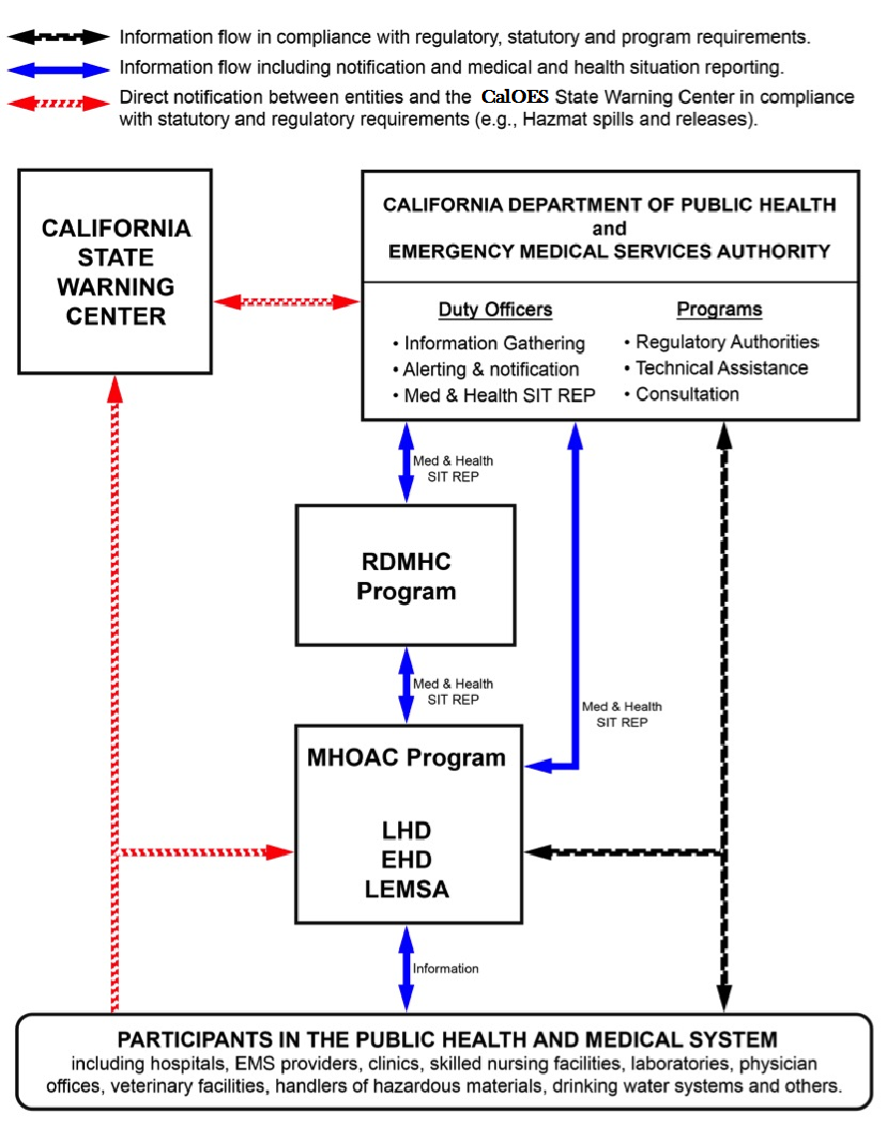
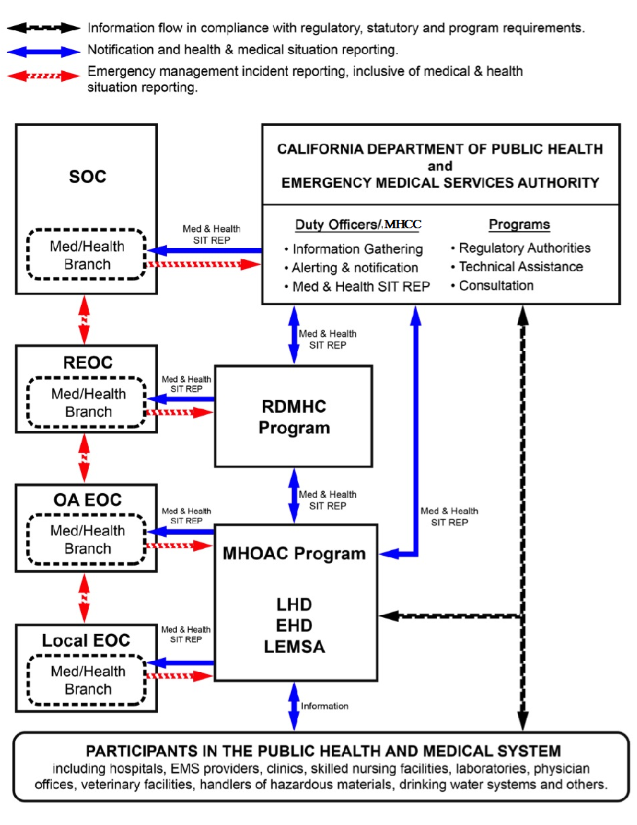

Notification Process for Unusual Events and Emergency System Activation Field to State
SEMS Level | Entity | Initial Notification
Field | Field-Level Participants in the Public Health and Medical System, e.g.,  - Hospitals  - EMS Providers  - Community Clinics  - Skilled Nursing Facilities  - Public Water Systems  - Public Health Laboratories | Notify local and State agencies in accordance with statutory and regulatory requirements and local policies and procedures.
Local Gov't | Public Health and Medical Agencies:  - LHD EHD Local Emergency Medical Services Agency (LEMSA) | Notify local and State agencies in accordance with statutory and regulatory requirements and local policies and procedures.  Notify the Medical and Health Operational Area Coordinator (MHOAC).  Local Health Department (LHD)/Environmental Health Departments (EHDs): Notify the California Department of Public Health (CDPH) Duty Officer Program (either directly or via the MHOAC Program) or Medical and Health Coordination Center (MHCC) if activated.
OA | MHOAC Program | Notify the Regional Disaster Medical Health Coordinator/Specialist (RDMHC/S) Program in affected region.  Notify the local emergency management agency in accordance with local policies and procedures.  Notify the CDPH and/or Emergency Medical Services Authority (EMSA) Duty Officer Programs (either directly or via the RDMHC Program).
Region | RDMHC/S Program | Notify the CDPH and/or EMSA Duty Officer Programs.  Notify the local emergency management agency in accordance with local policies and procedures.  Notify the MHOAC Program(s) in unaffected Operational Areas (OA) within the Mutual Aid Region to inform and provide advance warning if requests for assistance are anticipated.
State | CDPH and EMSA Duty Officer Programs | Notify State agencies in accordance with policies and procedures.  Notify the RDMHC/S Programs in other Mutual Aid Regions if assistance is required or anticipated.
State | Cal OES State Warning Center | Notify State agencies, including California Governor's Office of Emergency Services (Cal OES), in accordance with policies and procedures.

Notification Process for Unusual Events and Emergency System Activation State to Field
SEMS Level | Entity | Initial Notification
State | Cal OES State Warning Center | Notify the CDPH and EMSA Duty Officer Programs.
State | CDPH and EMSA  Duty Officer Programs | Notify State agencies in accordance with policies and procedures.  Notify the RDMHC Program in accordance with policies and procedures: request acknowledgement of notification if a Medical and Health Situation Report is expected; escalate to the MHOAC Program if acknowledgement of notification is not received from the RDMHC/S Program within 15 minutes. Notify the RDMHC/S Program by email if no Medical and Health Situation Report is expected by CDPH and/or EMSA.  Notify LHD/EHDs in accordance with policies and procedures and field-level entities in accordance with statutory and regulatory requirements for specific functions.
Region | RDMHC/S Program | Notify the MHOAC Program immediately if the State has requested a Medical and Health Situation Report. Otherwise, notify the MHOAC Program in accordance with policies and procedures.  Notify emergency management agencies in accordance with policies and procedures, including the Cal OES Regional Duty Officer (or Regional Emergency Operations Center [REOC] if activated).
OA | MHOAC Program | Notify local agencies (LHD, EHD, LEMSA, emergency management) in accordance with local policies and procedures.
Local Gov't | Public Health and Medical Agencies:  - LHD  - EHD  - LEMSA | Notify appropriate field-level entities in accordance with local policies and procedures.

Medical and Health Situation Report Unusual Events and Emergency System Activation
SEMS Level | Entity | Activity
Field | Field-Level Participants in the Public Health and Medical System, e.g.,  - Hospitals  - EMS Providers  - Community Clinics  - Skilled Nursing Facilities Public Water Systems Public Health Laboratories  - Dialysis Facilities  - Home Health/Hospice/Extended Care Facilities  - Ambulatory Surgery Centers  - Urgent Care Centers | Provide situational information to the appropriate local agency (e.g., LHD, EHD, LEMSA or MHOAC Program) in accordance with local policies and procedures.
Local Gov't | Public Health and Medical Agencies:  - LHD  - EHD  - LEMSA | Provide situational information to the MHOAC Program in accordance with local policies and procedures.
OA | MHOAC Program | Within two hours of incident recognition, prepare and submit initial Medical and Health Situation Report to: (1) RDMHC/S Program; (2) CDPH and/or EMSA Duty Officer Programs (or MHCC if activated); and (3) emergency management agency for the OA (or OA Emergency Operations Center [EOC] if activated) in accordance with local policies and procedures. Under pressing circumstances, the initial Situation Report may be verbally delivered. Update as agreed or pursuant to change in status but no less than once per operational period.
Region | RDMHC/S Program | Confirm that the MHOAC Program submitted the Medical and Health Situation Report to CDPH and/or EMSA Duty Officer Programs and the emergency management agency for the OA (or OA EOC if activated) in accordance with policies and procedures.  Confirm that the Cal OES Regional Duty Officer (or REOC if activated) received the information contained in the Medical and Health Situation Report in accordance with policies and procedures.
State | CDPH and EMSA  Duty Officer Programs (or MHCC if activated) | Share information with State agencies in accordance with policies and procedures.  Incorporate relevant information from Medical and Health Situation Reports into the statewide Public Health and Medical Daily Situation Report and share with Cal OES, California Health and Human Services (CHHS), RDMHC/S Programs, MHOAC Programs and other stakeholders at least once per operational period.

The designation of Public Health and Medical Incident Level 1, 2, or 3 describes the need for resources. It is also important to assess and report the operational status of the Public Health and Medical System within the Operational Area. Public Health and Medical System Status is assessed using a color-coded system that describes conditions along a continuum from normal daily operations to major disaster. This system is generally modeled after the system developed to assess and report Health Care Surge Level described in CDPH’s Standards and Guidelines for Healthcare Surge During Emergencies.
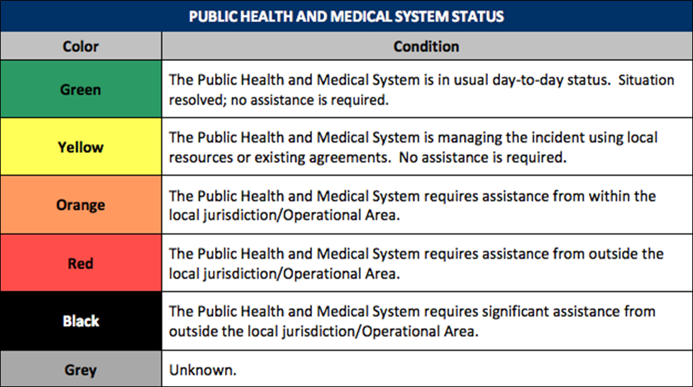

Appendix G: Forms

Situation Report Form:
https://www.cdph.ca.gov/Programs/EPO/CDPH%20Document%20Library/SitRep2-7c%20Fillable.pdf

Resource Request Form:
https://www.cdph.ca.gov/Programs/EPO/CDPH%20Document%20Library/ResourceRequestMedicalandHealthOPAREAtoREGIONSTATE.xls

Appendix H: Safety Checklist

[Each agency should fill in safety checklist information specific to their exercise.]

Site Control/Scene Safety

- Access to exercise sites and the [Control Cell and/or SimCell] is limited to exercise participants.
- All participants check in before the exercise.
- Media/Observers are escorted to designated areas and accompanied by an exercise controller at all times.
- Exercise staff are wearing the pre-determined badges, hats, and/or vests to clearly display their exercise roles.
- A perimeter fence or other types of barrier controls are in place.
- Site access points to the site or building have been identified and will be monitored during the duration of the exercise.
- Vehicle traffic is separated from pedestrian traffic on the site.
- Vehicle barriers at the perimeter and building maintain access for emergency responders, including large fire apparatus.
- Signs provide control of vehicles and people.
- All existing fire hydrants on the site are accessible.
- Floor plans posted show exits, entrances, location of security equipment, etc.

Participant Safety

- All participants are aware that there is a Safety Controller on scene.
- All participants know to use the phrase [“This is not a drill”] if an emergency arises that requires assistance.
- All participants are aware that they should notify emergency services and the closest controller if they observe another participant who is seriously ill or injured.
- All participants know to advise their venue’s controller or evaluator of any unauthorized persons.
- All participants are aware of exercise identification items, and will be able to identify exercise staff.
- All participants are aware of the exits, entrances, location of security equipment, etc.
- All participants are aware of and have agreed to the relevant weapons policy.

Appendix I: Acronyms
AAM | After Action Meeting
AAR | After Action Report
AAR/IP | After Action Report / Improvement Plan
AFN | Access and Functional Needs
ASPR | Administration for Strategic Preparedness and Response
C/E | Controller/Evaluator
CAHAN | California Health Alert Network
CAHF | California Association of Health Facilities
Cal OES | California Governor's Office of Emergency Services
Cal OSHA | California Division of Occupational Safety and Health
CBO | Community Based Organizations
CCLHO | California Conference of Local Health Officers
CDPH | California Department of Public Health
CERT | Community Emergency Response Team
CHA | California Hospital Association
C/ME | Coroner/Medical Examiner
CPCA | California Primary Care Association
CHHS | California Health and Human Services Agency
DHS | Department of Homeland Security
DOC | Department Operations Center
ED | Emergency Department
EEG | Exercise Evaluation Guides
EHD | Environmental Health Department
EMS | Emergency Medical Services
EMSA | Emergency Medical Services Authority
EMSAAC | Emergency Medical Services Administrators Association of California
EOC | Emergency Operation Center
EOM | California Public Health and Medical Emergency Operations Manual
EOP | Emergency Operations Plan
EPO | California Department of Public Health Emergency Preparedness Office
ETA | Estimated Time of Arrival
ExPlan | Exercise Plan
FAC/FIC | Family Assistance Center / Family Information Center
FBI | Federal Bureau of Investigation
FEMA | Federal Emergency Management Agency
FOUO | For Official Use Only
FSE | Full Scale Exercise
HAZMAT | Hazardous Materials
HCC | Hospital Command Center
HICS | Hospital Incident Command System
HIPAA | Health Insurance Portability and Accountability Act
HPP | Hospital Preparedness Program
HSEEP | Homeland Security Exercise and Evaluation Program
IAP | Incident Action Plan
ICS | Incident Command System
IP | Improvement Plan
JIC | Joint Information Center
JIS | Joint Information System
JRIC | Joint Regional Intelligence Center
JTTF | Joint Terrorism Task Force
LEMSA | Local Emergency Medical Services Authority
LHD | Local Health Department
MCI | Mass Casualty Incident
MHCC | Medical and Health Coordination Center
MHOAC | Medical/Health Operational Area Coordinator Program
MOU | Memorandum of Understanding
MRC | Medical Reserve Corps
MRSE | Medical Response and Surge Exercise
MSEL | Master Scenario Events List
NGO | Non-governmental organization
NHICS | Nursing Home Incident Command System
NIMS | National Incident Management System
OA | Operational Area
OEM | Office of Emergency Management
OES | California Governor’s Office of Emergency Services
PHEP | Public Health Emergency Preparedness
POC | Point of Contact
PPE | Personal Protective Equipment
RDMHC | Regional Disaster Medical Health Coordinator
RDMHS | Regional Disaster Medical Health Specialist
REOC | Regional Emergency Operation Center
SEMS | Standardized Emergency Management System
SimCell | Simulation Cell
SitMan | Situation Manual
SME | Subject Matter Expert
SOC | State Operations Center
SWAT | Special Weapons and Tactics Team
SWMHE | Statewide Medical and Health Exercise
TLO | Terrorism Liaison Officer
TTX | Tabletop Exercise
UC | Unified Command
VIP | Very Important Person

. After tailoring the document to your jurisdiction/organization/facility, be sure to update the Table of Contents by right-clicking on it and selecting “update field.”
. The Health Care Preparedness and Response Capabilities were released by the Administration for Strategic Preparedness and Response (ASPR) in December of 2016. They replace the 2011 – 2016 Hospital Preparedness Program (HPP) capabilities.
. From FEMA’s Emergency Management Institute Exercise Design Guidelines, in “Unit 4: Exercise Design Steps.”
. From FEMA’s Emergency Management Institute Exercise Design Guidelines, in “Unit 4: Exercise Design Steps.”
. Standardized Emergency Management System
. Source: CDPH Emergency Operations Manual, July 2011

